**DAILY ONLINE ACTIVITIES SUMMARY**

|  |  |  |  |  |  |  |  |  |
| --- | --- | --- | --- | --- | --- | --- | --- | --- |
| **Date:** | **2-06-2020** | | | | | **Name:** | **Kavya** | |
| **Sem & Sec** | **6th & A** | | | | | **USN:** | **4al17cs041** | |
| **Online Test Summary** | | | | | | | | |
| **Subject** | | **Computer Graphics** | | | | | | |
| **Max. Marks** | | **30** | | **Score** | | | **30** | |
| **Certification Course Summary** | | | | | | | | |
| **Course** | **Automated Analytics from Oracle Analytics Cloud and Machine Learning with Data Visualizations! Hands-on with Quizzes!** | | | | | | | |
| **Certificate Provider** | | | **Udemy** | | **Duration** | | | **3.5 hours** |
| **Coding Challenges** | | | | | | | | |
| **Problem Statement:1.** Given an array of positive integers. Write a C Program to find inversion count of array.  2. Write a program to check if given linked list has a loop or not  3. Python program to return a list containing first and last element using list slicing method | | | | | | | | |
| **Status:Yes,I have uploaded all the programs.** | | | | | | | | |
| **Uploaded the report in Github** | | | | | **yes** | | | |
| **If yes Repository name** | | | | | [**https://github.com/kavya-077/DAILY-STATUS**](https://github.com/kavya-077/DAILY-STATUS) | | | |
| **Uploaded the report in slack** | | | | | **yes** | | | |

Online Test Details: (Attach the snapshot and briefly write the report for the same)

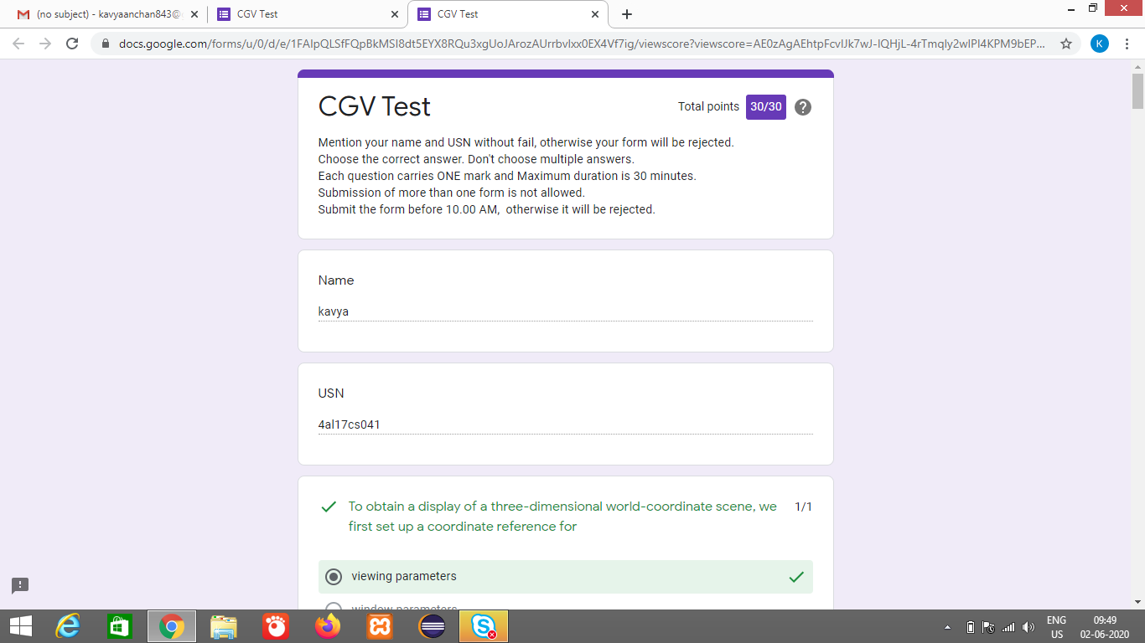

Certification Course Details: (Attach the snapshot and briefly write the report for the same)

**Automated Analytics from Oracle Analytics Cloud and Machine Learning with Data Visualizations! Hands-on with Quizzes!**

**What we’ll learn**

* Identify Cluster in your Data
* Build and Apply ML Models
* Machine Learning with Visualization
* Regression Analysis
* Correlation Analysis
* Build Visualization with SaaS Applications
* One Click Advanced Analytic Functions
* Connecting Autonomous DW and Essbase
* Data Sets from Big Data, Snowflake and other DBs
* Managing Data Sources
* Data Flow Advanced Topics
* Data Aggregation with Data Flow
* Advanced Visualization with Picto Charts
* Modern Business Intelligence

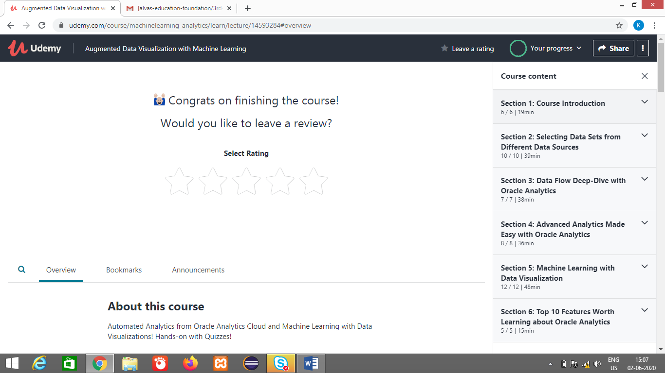

Coding Challenges Details: (Attach the snapshot and briefly write the report for the same)

<https://github.com/kavya-077/DAILY-STATUS>

<https://github.com/alvas-education-foundation/kavya-OCA>